

Darshan University

A Project Report on

**“Employee Management System”**

Under the subject

**Software Engineering (2301CS405)**

B. Tech, Semester – IV

Computer Science & Engineering Department

|  |  |
| --- | --- |
| Submitted By | |
| Student Name: Ida Gaurav R. | Enrollment No.: 24010101637 |
| Academic Year  (2024-2025) | |
| Internal Guide  Prof. R. B. Gondaliya  Darshan University | Dean-DIET  Dr. Gopi Sanghani  Darshan University |

|  |  |
| --- | --- |
|  | **Computer Science & Engineering Department**  **Darshan University** |

**DECLARATION**

We hereby declare that the SRS, submitted along with the **Software Engineering** **(2301CS405)** for entitled **“Employee Management System”** submitted in partial fulfilment for the Semester-5 of **Bachelor Technology (B. Tech)** in **Computer Science and Engineering (CSE)** Departmentto Darshan University, Rajkot, is a record of the work carried out at **Darshan University, Rajkot** under the supervision of R. B. Gondaliya and that no part of any of report has been directly copied from any students’ reports, without providing due reference.

(Ida Gaurav R.)

Student’s Signature

Date: __________

|  |  |
| --- | --- |
|  | **Computer Science & Engineering Department**  **Darshan University** |

**CERTIFICATE**

This is to certify that the SRS on **“Employee Management System” has** been satisfactorily prepared by **Ida Gaurav R.** (**24010101637**) under my guidance in the fulfillment of the course **Software Engineering (2301CS405)** work during the academic year 2024-2025.

|  |  |  |
| --- | --- | --- |
| Internal Guide  Prof. R. B. Gondaliya  Darshan University |  | Dean-DIET  Dr. Gopi Sanghani  Darshan University |

**Acknowledgement**

I wish to express my sincere gratitude to my project guide Prof. R. B. Gondaliyaand all the faculty members for helping me through my project by giving me the necessary suggestions and advices along with their valuable co- ordination in completing this work.

I also thank my parents, friends and all the members of the family for their precious support and encouragement which they had provided in completion of my work. In addition to that, I would also like to mention the Darshan University personals who gave me the permission to use and experience the valuable resources required for the project from the University premises.

Thus, in conclusion to the above said, I once again thank the faculties and members of **Darshan University** for their valuable support in completion of the project.

Thanking You

**Ida Gaurav R.**

**ABSTRACT**

The Employee Management System is a system designed to computerize and streamline the daily administrative and managerial tasks related to employee management within an organization. This system aims to transition traditional manual processes into a fully digital solution. The project includes features that are often missing in manual systems, such as secure user login for employees, managers, and admins, real-time task assignment and tracking, and leave management.

It also provides an admin login facility, enabling the admin to manage employee records, assign managerial roles, and update privileges. Managers can oversee tasks, roles, and department assignments for employees, while employees can log in to view tasks, update their status, check salary details, and apply for leaves.

The system is designed with essential features such as adding, viewing, updating, and deleting employee details, granting or revoking user permissions, and generating leave and task reports. Its primary purpose is to reduce human effort, enhance accuracy, and increase the efficiency of employee management operations.

**Table of Contents**

List of Figures I

List of Tables II

1 Introduction 1

1.1 Product perspective 1

1.2 Product features 1

1.2.1 There are three different users who will be using this product: 1

1.2.2 The features that are required for the Admin are: 1

1.2.3 The features that are required for the Manager are: 1

1.2.4 The features that are required for the Employee are: 1

1.3 Functional Requirement 1

1.3.1 Admin 1

1.3.2 Manager 2

1.3.3 Employee 2

1.4 Non-Functional Requirement 2

1.4.1 Usability: 2

1.4.2 Accuracy: 2

1.4.3 Availability: 2

1.4.4 Maintainability: 2

2 Design and Implementation Constraints 3

2.1 Use case diagram 3

2.2 Activity diagram and Swimlane diagram 4

2.3 Sequence diagram 6

2.4 State diagram 7

2.5 Class diagram 9

2.6 Data flow diagram 10

2.6.1 Context diagram (level-0) 10

2.6.2 DFD Level-1 10

3 External interface requirement (Screens) 11

3.1 Screen-1: Assigning Task 11

3.2 Screen-2: Change Department 12

3.3 Screen-3: Get Salary Detail 13

4 Database design 14

4.1 List of Tables 14

5 Stories and Scenario 14

5.1 Story-1: Add New Book in Library Catalogue 14

5.1.1 Scenario# S1.1 14

5.1.2 Scenario# S1.2 14

5.1.3 Scenario# S1.3 14

5.2 Story-2: Search Book 15

5.3 Story-3: Manage due date for borrowed book 15

5.4 Story-4: Renew book 15

5.5 Story-5: Generate a report on book usage and availability 15

6 Test cases 16

7 References 20

# List of Figures

Figure 2.1‑1 Use case diagram for Employee Management System 3

Figure 2.2‑1 Activity diagram for Add Employee 4

Figure 2.2‑2 Swimlane diagram for Add Employee 5

Figure 2.3‑1 Sequence diagram for Assigning task 6

Figure 2.4‑1 State diagram of Leave 7

Figure 2.4‑2 State diagram for Task 8

Figure 2.5‑1 Class diagram for Employee Management System 9

Figure 2.6‑1 Context diagram for Employee Management System 10

Figure 2.6‑2 DFD level-1 for Employee Management System 10

Figure 3.1‑1 Screen-1: Assigning Task 11

Figure 3.2‑1 Screen-2: Change Department 12

Figure 3.3‑1 Screen-3: Get Salary Detail 13

# List of Tables

Table 3.1‑1 Screen element of Registration form 10

Table 3.2‑1 Screen element of Login form 11

Table 3.3‑1 Screen element of Add borrower book 12

Table 4.1‑1 Table: Book 13

Table 4.1‑2 Table: Borrower 13

Table 4.1‑3 Table: Staff 13

Table 4.1‑4 Table: Student 13

# Introduction

## Product perspective

The **Employee Management System** is designed to streamline and digitize the management of employee-related tasks and processes. This system replaces manual processes with a comprehensive internet-based application that supports multiple user roles, ensuring efficiency and accuracy in managing employees' information, tasks, and privileges. It provides functionality for administrators, managers, and employees, catering to small and medium-sized organizations.

## Product features

### User Roles:

* Admin: Responsible for managing employee records and system privileges.
* Manager: Oversees employees, their roles, tasks, and leave management.
* Employee: Performs assigned tasks, applies for leaves, and checks salary details.

### Features for Admin:

* Add new employee records to the system.
* Edit employee details, such as contact information and department.
* Grant or revoke privileges for employees.
* Assign an employee as a manager.
* Deallocate a manager back to a standard employee role.
* View and manage the list of all employees.
* Secure login and logout functionality.

### Features for Manager:

* Approve or deny leave requests submitted by employees.
* Assign roles and responsibilities to employees.
* Assign tasks and monitor their progress.
* Update the department assignment of an employee.
* View leave records of their team members.
* Secure login and logout functionality.

### Features for Employees:

* View assigned tasks and update their status.
* Apply for leaves and track their approval status.
* Check salary details and payment history.
* Secure login and logout functionality.

## Functional Requirement

### Admin:

* Add Employee: The system shall allow the admin to input employee details such as name, role, and department.
* Edit Employee Details: The system shall enable the admin to update employee information when required.
* Grant Privileges: Admin can assign specific access permissions to employees.
* Revoke Privileges: Admin can remove specific permissions from employees.
* Assign Manager: Admin can designate an employee as a manager
* Deallocate Manager: Admin can revoke managerial roles and assign them back as standard employees.
* Manage Employee Records: Admin can view, search, and manage the database of all employees.
* Authentication: Admin must log in securely before accessing the system.

### Manager:

* Approve/Deny Leave Requests: Managers can view and respond to leave applications from employees.
* Assign Roles: Managers can assign or update employee roles within their department.
* Assign Tasks: Managers can allocate tasks and set deadlines for employees.
* Update Employee Department: Managers can reassign employees to other departments.
* View Leave Records: Managers can track and view approved leaves for their team.
* Authentication: Managers must log in securely before accessing the system.

### Employee:

* Task Status Update: Employees can update their task status (e.g., "In Progress," "Completed").
* Apply for Leaves: Employees can submit leave requests for managerial approval.
* View Salary Details: Employees can check salary breakdowns and payment history.
* Authentication: Employees must log in securely before accessing the system.

## Non-Functional Requirement

### Usability:

* The UI should be simple enough for everyone to understand and get the relevant information without any special training. Different languages can be provided based on the requirements.

### Accuracy:

* The data stored about the books and the fines calculated should be correct, consistent, and reliable.

### Availability:

* The System should be available for the duration when the library operates and must be recovered within an hour or less if it fails. The system should respond to the requests within two seconds or less.

### Maintainability:

* The software should be easily maintainable and adding new features and making changes to the software must be as simple as possible. In addition to this, the software must also be portable.

# Design and Implementation Constraints

## Use case diagram

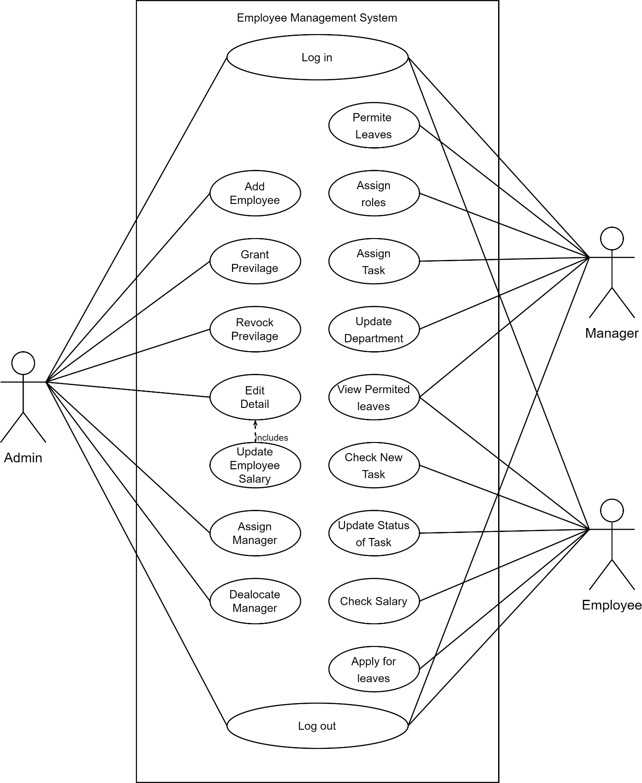

Figure ‑ Use case diagram for Employee Management System

## Activity diagram and Swimlane diagram

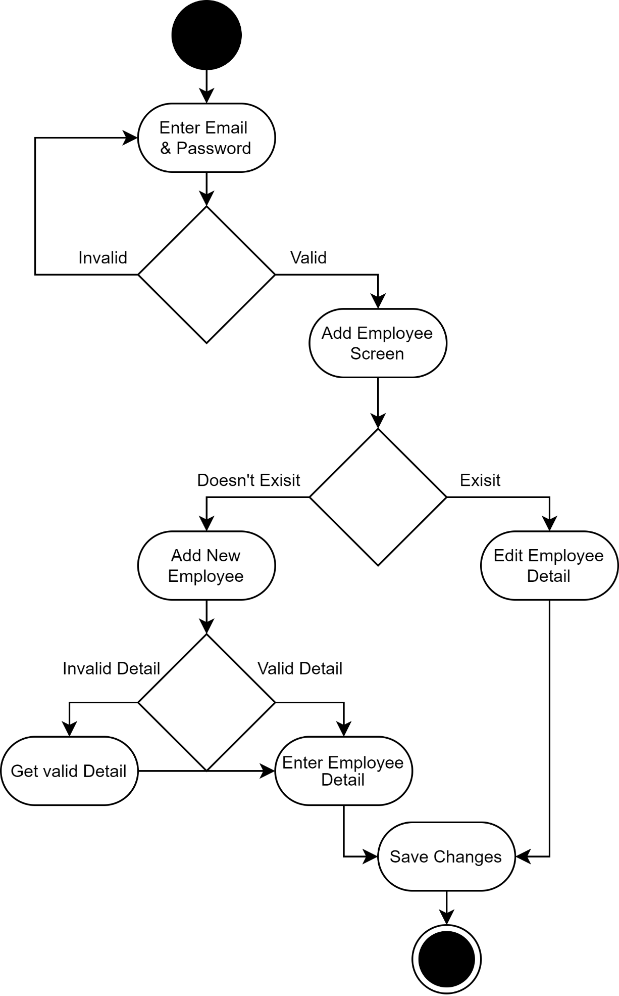

Figure ‑ Activity diagram for Add Employee

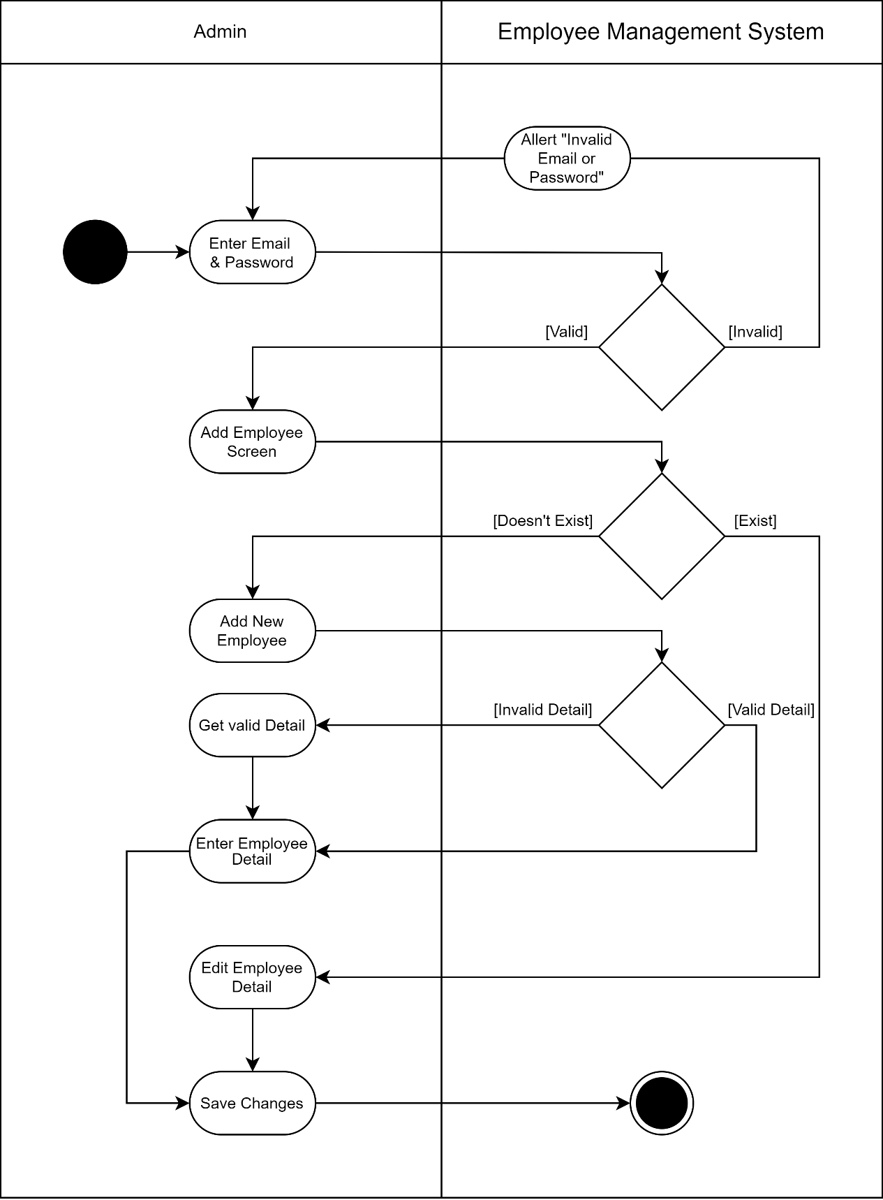

Figure ‑ Swimlane diagram for Add User

## Sequence diagram

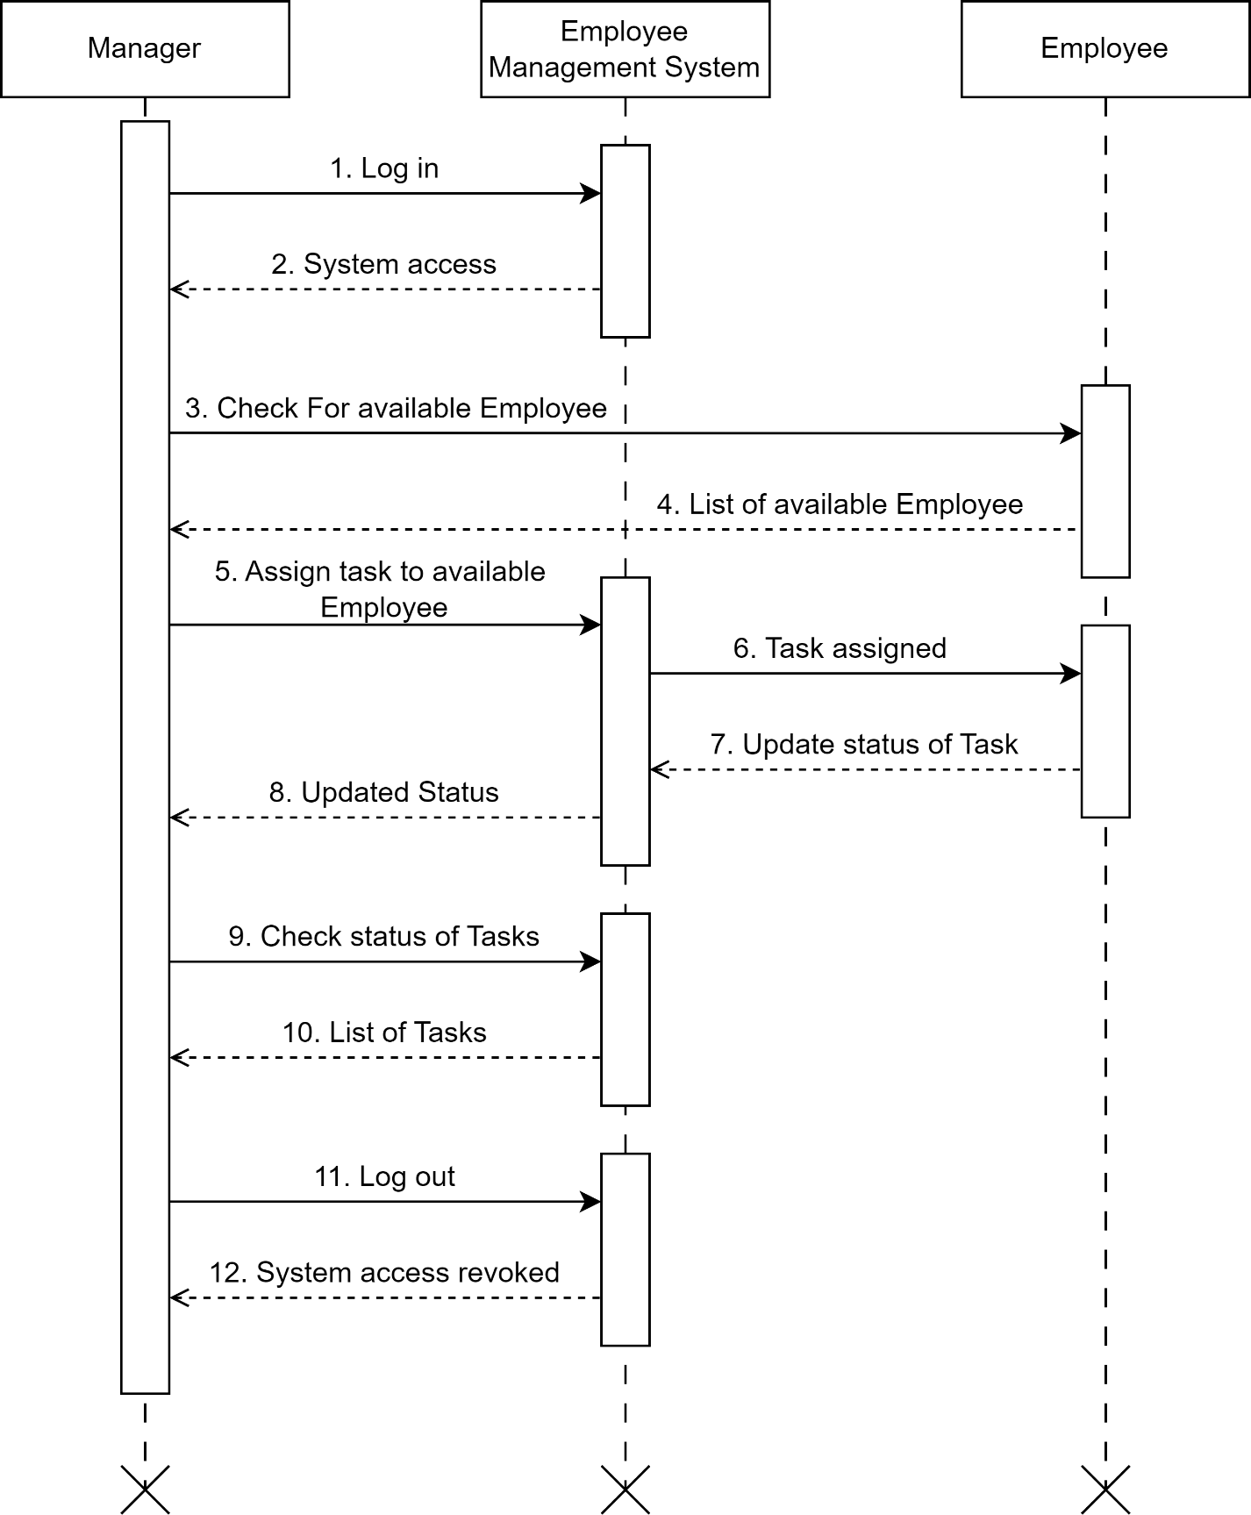

Figure ‑ Sequence diagram for Assigning Task

## State diagram

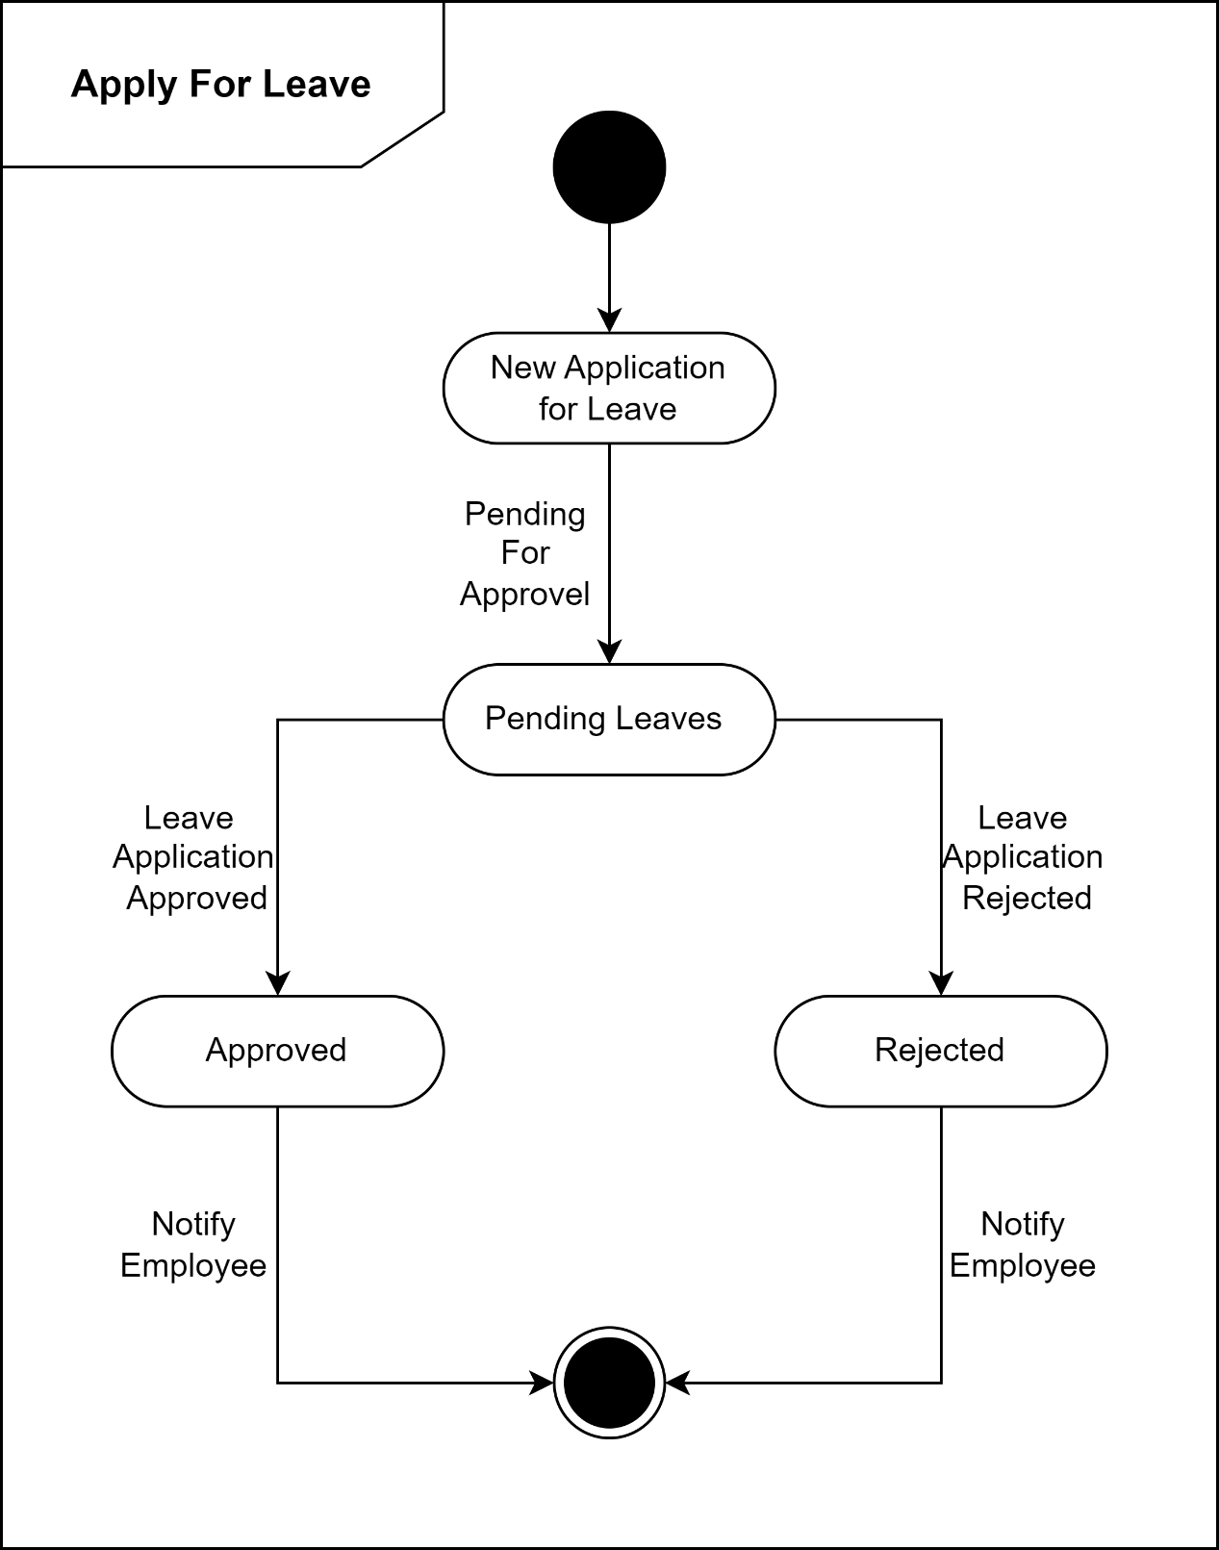

Figure ‑ State diagram of Leave

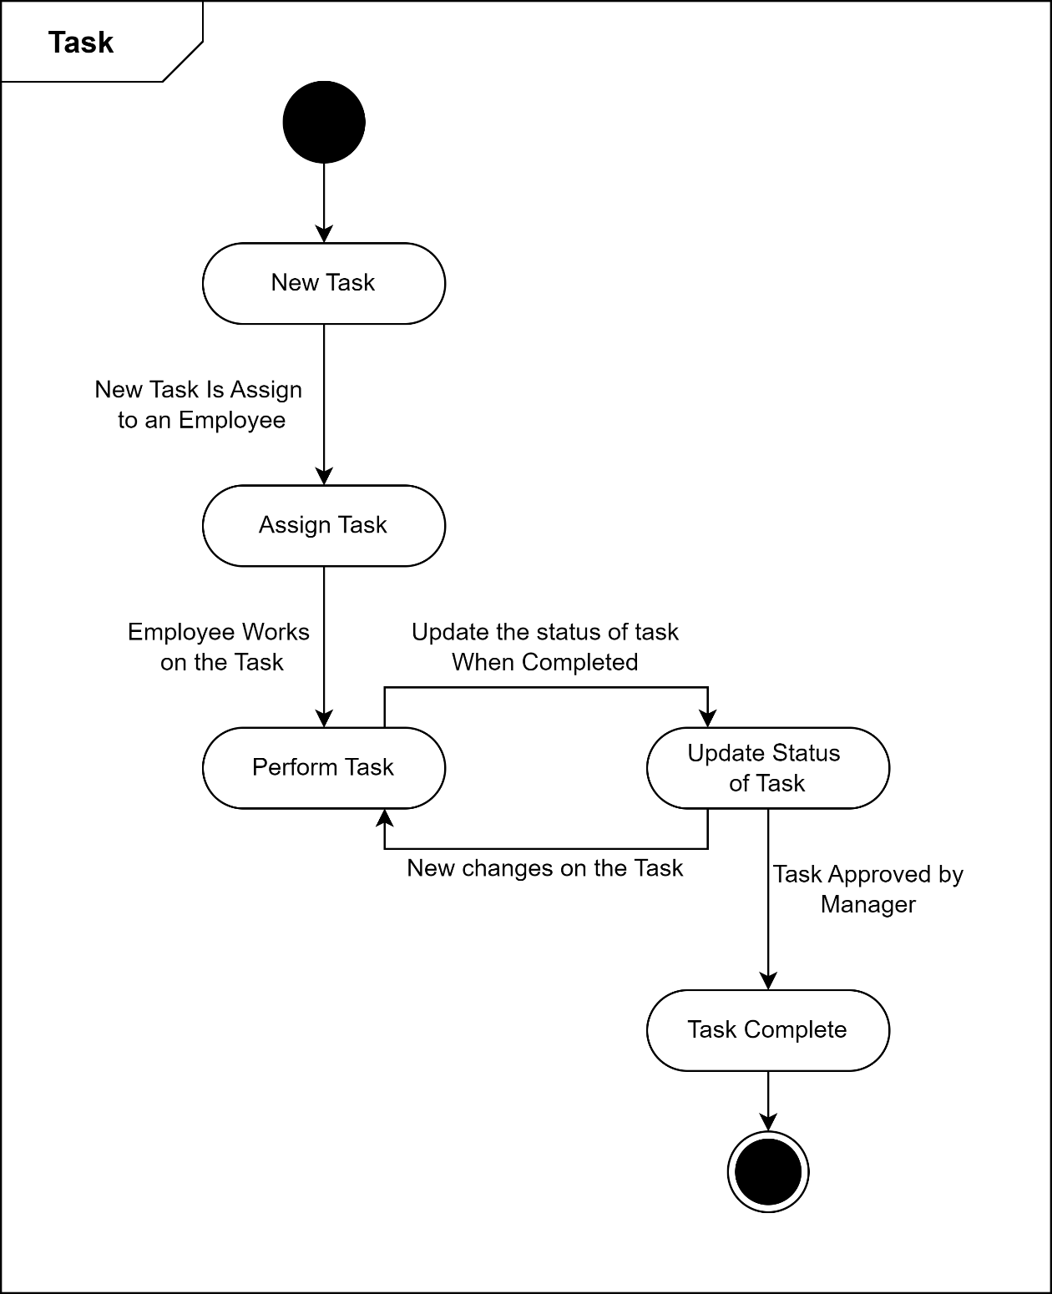

Figure ‑ State diagram for Task

## Class diagram

Figure ‑ Class diagram for Employee Management System

## Data flow diagram

### Context diagram (level-0)

Figure ‑ Context diagram for Employee Management System

### DFD Level-1

Figure ‑ DFD level-1 for Employee Management System

# External interface requirement (Screens)

## Screen-1: Assigning Task

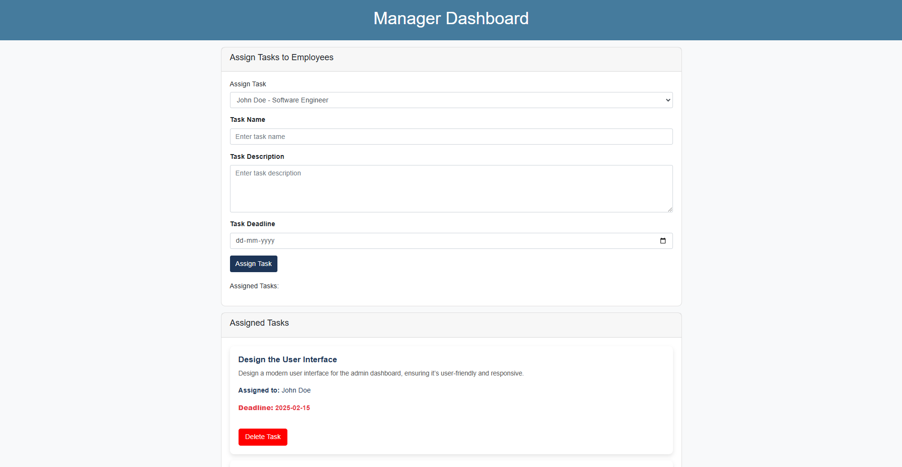

Figure ‑ Screen-1: Assigning Task

**Purpose:** This screen will allow manager to assign tasks to specified employee through system. To assign task, the following information will be encoded in the system.

Table ‑ Screen element of Assigning Task

|  |  |  |  |  |  |
| --- | --- | --- | --- | --- | --- |
| Sr. | Screen Element | Input Type | O/M | 1/N | Description |
| 1 | Employee name | Dropdown | M | 1 | Employee dropdown should be editable change or select Employee. |
| 2 | Task name | Textbox | M | 1 | Task name field should be editable and accept the task name. |
| 3 | Task description | Text area | M | 1 | Task description should be editable and accept the detailed task description. |
| 4 | Task deadline | Date | M | 1 | Task deadline field should be editable and accept the deadline date of the task. |
| 5 | Assign task | Button | ------ | ------ | Assign task is a button for assign task to the specified employee. |

## Screen-2: Change Department

Figure ‑ Screen-2: Change Department

**Purpose:** This screen will be used by the manager to change department of an employee from the system. The manager will select the correct combination of employee name and new department of employee to change their department from the system.

Table ‑ Screen element of Change Department

|  |  |  |  |  |  |
| --- | --- | --- | --- | --- | --- |
| Sr. | Screen Element | Input Type | O/M | 1/N | Description |
| 1 | Employee name | Dropdown | M | 1 | Employee dropdown should be editable to change or select Employee. |
| 2 | Department name | Dropdown | M | 1 | Department name should be editable to change or select department. |
| 3 | Update department | Button | ------ | ------ | Update department is a button for changing department of specified employee. |

## Screen-3: Get Salary Detail

Figure ‑ Screen-3: Get Salary Detail

**Purpose:** This module will allow the employees to get/download their salary slip.

Table ‑ Screen element of Get Salary Detail

|  |  |  |  |  |  |
| --- | --- | --- | --- | --- | --- |
| Sr. | Screen Element | Input Type | O/M | 1/N | Description |
| 1 | Download salary slip | Button | ----- | ----- | Download salary slip is a button to download current months salary slip of an employee. |

# Database design

## List of Tables

* Admin
* Manager
* Employee
* Salary
* Task
* Leave
* Department

Table ‑ Table: Admin

|  |  |  |  |  |
| --- | --- | --- | --- | --- |
| Column | Data Type | Null | Keys & Constrains | Default Value & Description |
| AdminID | int | NN | PK (Auto Increment) |  |
| AdminName | varchar(100) | NN |  |  |
| AdminEmail | varchar(100) | AN |  |  |
| AdminPassword | varchar(100) | AN |  |  |

Table ‑ Table: Manager

|  |  |  |  |  |
| --- | --- | --- | --- | --- |
| Column | Data Type | Null | Keys & Constrains | Default Value & Description |
| ManagerID | int | NN | PK (Auto Increment) |  |
| ManagerName | varchar(100) | NN |  |  |
| ManagerEmail | varchar(100) | AN |  |  |
| ManagerPassword | varchar(100) | AN |  |  |
| EmployeeId | int | NN | FK | Reference of Employee from Employee Table. |

Table ‑ Table: Employee

|  |  |  |  |  |
| --- | --- | --- | --- | --- |
| Column | Data Type | Null | Keys & Constrains | Default Value & Description |
| EmployeeId | int | NN | PK (Auto Increment) |  |
| EmployeeName | varchar(100) | AN |  |  |
| EmployeeEmail | Boolean | AN |  |  |
| EmployeePassword | varchar(100) | AN |  |  |
| ManagerId | int | AN | FK | Reference of Manager from Manager Table. |
| DepartmentId | int | NN | FK | Reference of Department from Department Table. |

Table ‑ Table: Salary

|  |  |  |  |  |
| --- | --- | --- | --- | --- |
| Column | Data Type | Null | Keys & Constrains | Default Value & Description |
| SalaryID | int | NN | PK (Auto Increment) |  |
| NetSalary | Int | AN |  |  |
| BasicPay | int | AN |  |  |
| Allowances | int | AN |  |  |
| Deduction | int | AN |  |  |
| EmployeeId | int | NN | FK | Reference of Employee from Employee Table. |

Table -5 Table: Task

|  |  |  |  |  |
| --- | --- | --- | --- | --- |
| Column | Data Type | Null | Keys & Constrains | Default Value & Description |
| TaskId | int | NN | PK (Auto Increment) |  |
| TaskTitle | varchar(100) | AN |  |  |
| TaskDescription | Boolean | AN |  |  |
| TaskDeadline | varchar(100) | AN |  |  |
| Status | Boolean | AN |  |  |
| ManagerId | int | NN | FK | Reference of Manger from Manager Table. |
| EmployeeId | int | NN | FK | Reference of Employee from Employee Table. |

Table ‑6 Table: Leave

|  |  |  |  |  |
| --- | --- | --- | --- | --- |
| Column | Data Type | Null | Keys & Constrains | Default Value & Description |
| RequestId | int | NN | PK (Auto Increment) |  |
| RequestReason | varchar(100) | AN |  |  |
| StartDate | DateTime | AN |  |  |
| EndDate | DateTime | AN |  |  |
| Status | Boolean | AN |  |  |
| ManagerId | int | AN | FK | Reference of Manager from Manager Table. |
| EmployeeId | int | NN | FK | Reference of Employee from Employee Table. |

Table ‑7 Table: Department

|  |  |  |  |  |
| --- | --- | --- | --- | --- |
| Column | Data Type | Null | Keys & Constrains | Default Value & Description |
| DepartmentId | int | NN | PK (Auto Increment) |  |
| DepartmentName | varchar(100) | NN |  |  |
| EmployeeCount | int | AN |  |  |

# Stories and Scenario

## Story-1: Add New Book in Library Catalogue

|  |  |  |
| --- | --- | --- |
| *Story # S1* | : | As a Librarian,  I want to add a new book in library catalogue  So that everyone can easily find and borrow it. |
| Priority | **:** | High |
| Estimate | **:** | XL |
| Reason | **:** | The addition of a new book to the library catalogue is crucial for ensuring that the library's collection is up-to-date and accessible to everyone. |

### Scenario# S1.1

|  |  |  |
| --- | --- | --- |
| *Scenario# S1.1* | : | Adding a New Book with Valid Information |
| Prerequisite | **:** | Librarian is logged in to the Library management system. |
| Acceptance Criteria | **:** | **Given:**  The Librarian is navigated to the library catalog management page. Valid book information, including title, author, ISBN, and other relevant details is added.  **When:**  The librarian selects the "Add New Book" option  And The librarian enters valid book details  The librarian clicks the "Save" button to add the book to the catalog.  **Then t**he system successfully adds the book to the catalog and the librarian receives a confirmation message with the book's identification number. |

### Scenario# S1.2

|  |  |  |
| --- | --- | --- |
| *Scenario# S1.2* | : | Adding a New Book with Invalid Information. |
| Prerequisite | **:** | The librarian is logged into the library management system. |
| Acceptance Criteria | **:** | **Given:** The librarian is on the library catalogue management page  **When:** The librarian selects the "Add New Book" option and the librarian enters an incomplete or incorrect book details and librarian clicks the "Save" button to add the book to the catalogue.  **Then t**he system displays error messages for the incorrect or missing information and the book is not added to the catalogue. |

### Scenario# S1.3

|  |  |  |
| --- | --- | --- |
| *Scenario# S1.3* | : | Attempting to Add a Duplicate Book |
| Prerequisite | **:** | The librarian is logged into the library management system and the librarian is on the library catalogue management page |
| Acceptance Criteria | **:** | **Given**: The book information, including title, author, ISBN, and other relevant details, is available and the book with the same ISBN is already in the catalogue.  **When**: User Clicks on “Add book” button. Enter a number of copies with the same book detail mentioned in the field.  **Then**: Generate unique book id, barcode and spine label for various book of same title. |

## Story-2: Search Book

|  |  |  |
| --- | --- | --- |
| *Story # S2* | : | As a Librarian or member,  I want to search for books by title, author, or keyword,  So that I can quickly find books that match my interests. |
| Priority | **:** | High |
| Estimate | **:** | M |
| Reason | **:** | Implementing a search functionality is essential for enhancing the user experience, as it allows librarian and member to efficiently discover and access the library's resources. |

## Story-3: Manage due date for borrowed book

|  |  |  |
| --- | --- | --- |
| *Story # S3* | : | As Librarian,  I want to manage due dates for borrowed books  So that I can ensure that books are returned on time and avoid overdue fines. |
| Priority | **:** | High |
| Estimate | **:** | M |
| Reason | **:** | Proper due date management is crucial for maintaining the library's collection and ensuring that books are available for all members. |

## Story-4: Renew book

|  |  |  |
| --- | --- | --- |
| *Story # S3* | : | As Librarian,  I want to renew a book that I have borrowed  So that I can extend my borrowing period if needed. |
| Priority | **:** | Medium |
| Estimate | **:** | M |
| Reason | **:** | Book renewal functionality is a convenience feature for librarian, allowing them to keep a book for an extended period if no one else has requested it. |

## Story-5: Generate a report on book usage and availability

|  |  |  |
| --- | --- | --- |
| *Story # S3* | : | As Librarian,  I want to generate reports on library usage and book availability  So that I can make informed decisions about library’s books. |
| Priority | **:** | Medium |
| Estimate | **:** | L |
| Reason | **:** | Reporting functionality helps librarians track the usage of library resources and make data-driven decisions to improve services and collections. |

# Test cases

|  |  |  |  |
| --- | --- | --- | --- |
| Project Name: | EMI Calculator | Test Designed by: | P. U. Jadeja |
| Module Name: | **Login** | **Test Designed date:** | 01-10-2023 |
| Release Version: | **1.0** | **Test Executed by:** | **R. B. Gondaliya** |
|  |  | **Test Execution date:** | 15-01-2023 |

|  |  |  |  |  |
| --- | --- | --- | --- | --- |
| Pre-condition: Web application should be accessible | | | | |
| Test Case ID | **Test Title** | **Test Type** | **Description** | **Test Case ID** |
| TC_001 | Login to web application with valid credential | Functional | Login to Library management system web application through valid credential | TC_001 |
| TC_002 | Login to web application with invalid credential | Functional | Login to Library management system web application through invalid credential | TC_002 |
| TC_003 | Varify login page elements | GUI | varify that all elements are availabe on login page | TC_003 |

|  |  |
| --- | --- |
| **Test Case Title** | Login to web application with valid credential |
| **Test Type** | Functional |
| **Test Priority** | High |
| **Pre-condition** | Web application should be accessible |

|  |  |  |  |  |  |  |  |
| --- | --- | --- | --- | --- | --- | --- | --- |
| **Test Step** | **Test Case Description** | **Expected Result** | **Actual Result** | **Status** | **Comment** | **Data** | **BUG ID** |
| 1 | Access Web application URL | The site launched properly | Site launched successfully | Pass |  | <https://accounts.google.com/ServiceLogin> |  |
| 2 | Enter valid Username in username field | Username field should be editable and accept the Username | Username input accepted | Pass |  | Username:  Rbgondaliya@gmail.com |  |
| 3 | Enter valid Password in Password field | Password field should be editable and accept the password and display as star or dot | Password input displayed in dot and accepted | pass |  | Password: rbgondaliya |  |
| 4 | Enter valid captcha code in captch field | Captch field should editable and accept captcha and captcha is case sensitive | Captcha input accepted | Pass | Step required when human action validation perform | get captcha from image which is near by captcha field |  |
| 5 | Click on login button | User should login into site and navigated to dashboard | User navigated to dashboard and username should br display in top of the right side. | pass |  |  |  |

|  |  |
| --- | --- |
| **Test Case Title** | Login to web application with invalid credential |
| **Test Type** | Functional |
| **Test Priority** | Medium |
| **Pre-condition** | Web application should be accessible |

|  |  |  |  |  |  |  |  |
| --- | --- | --- | --- | --- | --- | --- | --- |
| **Test Step** | **Test Case Description** | **Expected Result** | **Actual Result** | **Status** | **Comment** | **Data** | **Bug ID** |
| 1 | Verify that User is not able to Login with invalid Username and invalid Password | Should be display an error message enter wrong username or password | Display an error of wrong username and password | Pass |  |  |  |
| 2 | Verify that User is not able to Login with Valid Username and invalid Password | Should be display an error message enter wrong password | Display an error of wrong password | Pass |  |  |  |
| 3 | Verify that User is not able to Login with invalid Username and Valid Password | Should be display an error message User not found | Display an error Username not found | Pass |  |  |  |
| 4 | Verify that User is not able to Login with blank Username or Password | Set required field validation message for Username and Password | Display an error of wrong username and password | Fail | Not performa a validation function fix it |  | Bug_002 |

|  |  |
| --- | --- |
| **Test Case Title** | Varify login page elements |
| **Test Type** | GUI |
| **Test Priority** | Medium |
| **Pre-condition** | Web application should be accessible |

|  |  |  |  |  |  |  |  |
| --- | --- | --- | --- | --- | --- | --- | --- |
| **Test Step** | **Test Case Description** | **Expected Result** | **Actual Result** | **Status** | **Comment** | **Data** | **Bug ID** |
| 1 | Launch application with the given url | The site launched properly | Site launched successfully | Pass |  | <https://accounts.google.com/ServiceLogin> |  |
| 2 | Verify that the login screen contains elements such as Username, Password, Sign in button, Remember password check box, Forgot password link, and Create an account link. | All listed control displayed properly on the page | Login page loaded successfully | Pass |  |  |  |
| 3 | Verify that cursor is focused on “Username” text box on the page load | Cursor is focused in Username textbox | Cursor focus in Username textbox | Pass |  |  |  |
| 4 | Verify that tab functionality is working properly or not | When tab pressed cursor move in next control | Cursor moving in next control | Pass |  |  |  |
| 5 | Verify that all the fields such as Username, Password has a valid placeholder | All text fields have proper placeholder | All text fields have proper placeholder | Pass |  |  |  |
| 6 | Verify that the labels float upward when the text field is in focus or filled (In case of floating label) | When field is focused or filled, label display on top of the filled | When field is focus or filled, label display on top of the filled | Pass | step required when fields with floating label |  |  |
| 7 | verify that forgot password link working properly | when click on forgot password load forgot passworg page | forgot password link not working | Fail |  |  |  |

# References

* http://www.w3schools.com/html/html_intro.asp
* https://www.w3schools.com/php/default.asp
* https://www.javatpoint.com/uml